**SPRINT 4**

**DASHBOARD NODES FOR CREATING UI (WEB APP)**

|  |  |
| --- | --- |
| **TEAM ID** | **PNT2022TMID43096** |
| **PROJECT NAME** | **GAS LEAKAGE MONITORING AND ALERTING SYSTEM FOR INDUDTRIES** |

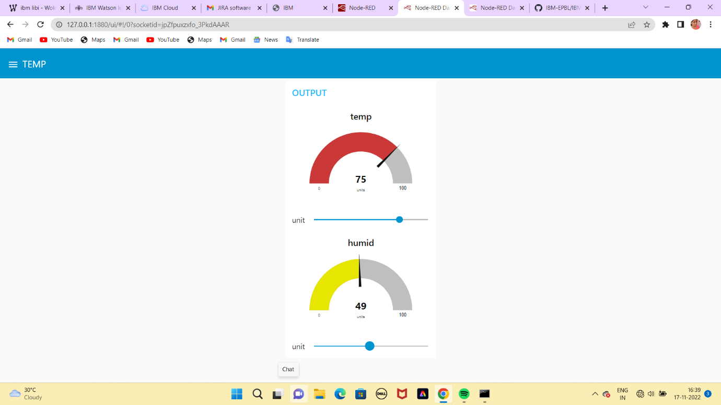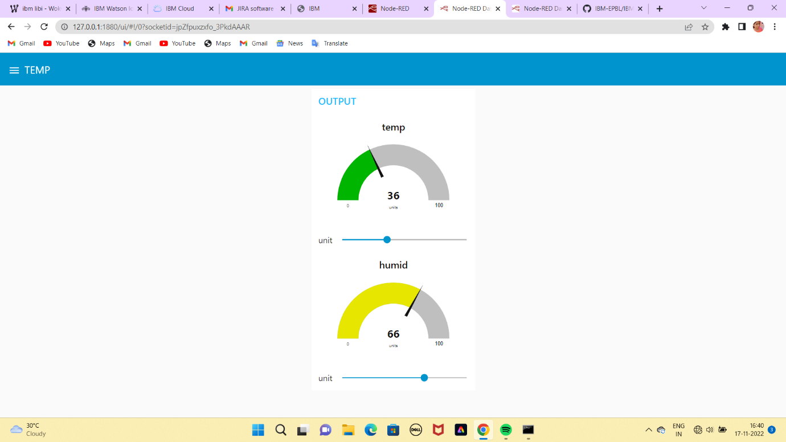

**RESULT :**

Output from Node-Red dashboard are successfully done.